# **Name: Abdurrahman Qureshi**

# **Roll No: 210451**

Practical No: 18

1. **Area of circle using parameterized constructor**

**CODE:**

Module Module1

Class Circle

Dim r, a As Integer

Sub New(ByVal r As Integer)

a = 3.14 * r * r

Console.WriteLine("Area of a circle : " & a)

End Sub

End Class

Sub Main()

Console.WriteLine("Spectre Scythe")

Dim obj As New Circle(7)

Console.ReadLine()

End Sub

End Module

**OUTPUT:**

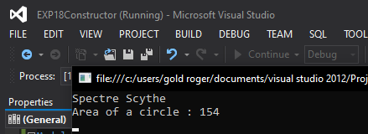

1. **Display any message at run time. (Using Constructor)**

**CODE:**

Module Module1

Class Line

Private l As Double

Public Sub New()

Console.WriteLine("Loading terrain...")

End Sub

Public Sub setlength(ByVal len As Double)

l = len

End Sub

Public Function getLength() As Double

Return l

End Function

End Class

Sub Main()

Console.WriteLine("Spectre Scythe")

Dim L As Line = New Line()

L.setlength(7.0)

Console.WriteLine("Length Of line:{0}", L.getLength())

Console.ReadKey()

End Sub

End Module

**OUTPUT:**

